Creating New Projects
One of the very first things you need to do to create a project is to choose an approach.
The approaches to start a project include the following:
Blank – clean schedule
New From Existing – copy from existing schedule
New From Excel – importing information from Excel
New From SharePoint Tasks List – shortcut to bring SharePoint tasks into your schedule
Get Started Wizard – guided approach with visuals to help individuals feel more comfortable working in a schedule
Template – public or private pre-built schedules that can be used as examples
If you do not have Internet access, you may not have all of these choices.
Office 365 or cloud users may have different choices depending on their organization’s configuration.
How to Start a New Project
Click the File tab
Click New
Click the desired item from the previews
If needed, click Create to obtain a copy of that item to start your schedule
Templates available are simply examples and may not map to your organization’s project management practices. Be sure to review the templates for modifications that you might need to make.
Saving a project
Saving a project is all about storing a project for quick and easy retrieval. You may choose to store your project on your computer, on a network location, or on a cloud storage solution. As each organization’s configuration is different, we will focus on the procedures for saving to your local computer.
How to Save a New Project
Click the File tab
Click Save or Save As
Click Computer
Click Browse
Navigate to the desired folder
Enter the desired name for the schedule
Click Save
The folder you just used with be available under Recent Folders to simplify this process for future new projects.
When making changes to the same project, you can use the Save icon on the Quick Access Toolbar as a fast method to ensure your project changes are being captures.
Opening a Project
Since opening projects is such a frequent task, you should take advantage of quick methods to do this. The following steps will help you optimize your environment for speedy retrieval of projects.
How to Open a Project
Click the File tab
Click Open
Click Computer
Click Browse
Navigate to the desired folder
Select the name for the schedule
Click Open
Click Recent Projects to quickly retrieve a project you have previously opened.
Pin a project to the top of the recent project list is you anticipate you will be using it on a regular basis.
Creating a New Project
When Project 2010 is initiated, a new blank project schedule will automatically appear.
To create a blank project schedule:
Click File → New
Backstage choices shown below will give you an array of choices of where to begin a new project schedule. As you click the various choices, options and additional data will appear on the right side of the view.
Double clicking Blank project or click Blank project and click Create will result in creating a blank project file
Recent Templates: Create a project from a recently used template
My templates: Template created my you and saved to your desktop
New from an existing project: Use an existing project schedule to create a new project
New project from Excel workbook: Columns in the Excel workbook will be mapped to fields within Project 2010. The import process is discussed in the next lesson.
New from Sharepoint task list: Project 2010 Professinal only. Tasks will be imported using the URL and security of the Sharepoint site.
Office.com templates: Create a new project from a template that would be downloaded from Office.com on-line
If the Quick Access Bar was customized to add the New button, pressing that button will create a new project schedule
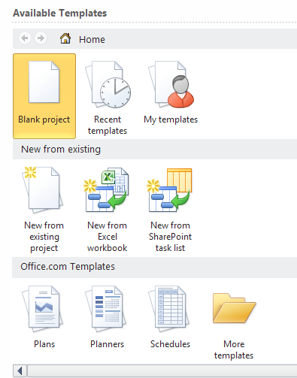
PLACEHOLDER
Creating a Project from an Excel Workbook
A project schedule can be created using an Excel Workbook task list. Keep in mind that the fields or columns that are being imported from Excel will be mapped to fields or columns within Project 2010. Pre-planning to know which Excel fields should be mapped to which Project 2010 fields would be helpful.
All options should be pre-set before importing tasks.
To create a project schedule from an Excel Workbook:
Click File → New → New From Excel Workbook
Navigate to the Excel file that contains the tasks to be imported into the schedule, click Open
Project 2010 Import Wizard will start running – Click Next
Select whether to use a new map that will be created or an existing Project import map. For this example we will create a new map. Click the radio button next the New Map and click Next
Import can start a new project file, append to the end of an existing project file or merge the data using a merge field. In this example we will create a new project schedule. Click As a new project and click Next.
When the data is brought into Project 2010, select if the data is to be mapped to the Task fields, Resource fields or Assignment fields. Click Tasks.
If the originating Excel file contains header or title information, click Import includes Headers. The system will remove this row (the first line only) as the header row. Click Next
The Task Mapping form will be used to view some of the data and map which Excel fields will be imported into which Project 2010 fields. Pull down the values in the Select worksheet name option and select the sheet name in Excel that contains the data to be imported. After the choice has been made, the data from the sheet will be available for viewing.
In the example below, the duration field from the Excel Workbook was able to be automatically mapped to the duration field in Project 2010. However, the Task Name field could not find a match. The correct field name for the task name field in Project 2010 is “Name”. Click the red error message (not mapped) and select the field name of Name. Repeat for other fields to be imported. Not all fields are required during the import process which allows the user to pick and choose which ones are appropriate to the schedule. Click Next to continue after all columns have been mapped.
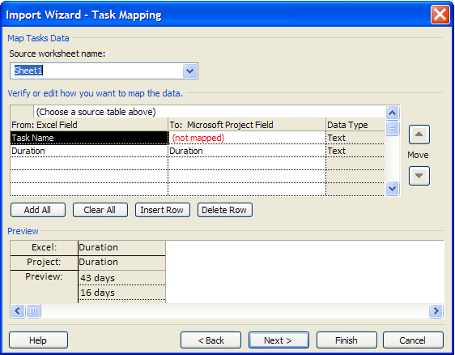
PLACEHOLDER
The next step offers the option to save the map for future reuse.
To skip saving the map, click Next.
To save the map, click Save Map and give the map a name.
An option will be available to use the Organizer to copy the import map into the Global.mpt and save it for future use. The Organizer will be discussed in Module 10.
Click Finish to start the import.
The new Project 2010 schedule will open with the columns imported.
Creating a Project from a SharePoint Task List
Project 2010 Professional allows for creating a new project by importing a task list from a SharePoint site. The user must have appropriate permissions to the access the SharePoint site and the URL path to insert into the form directing Project 2010 Pro to the location of the task list.
To import tasks from a SharePoint task list into Project 2010 Professional:
Click File → New → New from SharePoint Task List
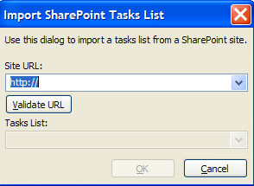
PLACEHOLDER
Enter the URL in the form as shown above and click Validate URL. A list of all the task lists included in the SharePoint site will be displayed. Select the appropriate list and click OK.
The list will be imported from the SharePoint site.
This is Pro only – Rolly should add a screen shot here.
Saving the Schedule
Project 2010 provides multiple file formats for a project schedule. The steps to save a file are very similar to other MS Office files.
To save the Project 2010 schedule:
Click File → Save as → select file location
Enter the file name in the File Name area
Click Save to complete the save. The file will be given a Project 2010 default file extension of .mpp
There is also an option to save the Project 2010 schedule in an alternative file format. Some of the formats are:
MS Project 2007
MS Project 2000-2003
MS Project template 2010 - .mpt file extension
MS Project template 2007 - .mpt file extension
MS Excel
PDF
XPS
XML
CVS
Text
Save and Send Options
A new feature in Project 2010 is the Save and Send from the backstage view. These options are an easy method of saving projects and sharing project schedules with others. There is also an option to send project files as an attachment to an email as well as publishing the project schedule to a SharePoint site (Project 2010 Pro users only).
To navigate to the options available for Save and Send:
Click File → Save and Send → select one of the options offered
The right side of the screen will change as options are selected
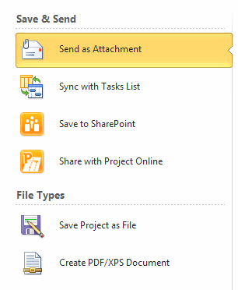
PLACEHOLDER
Send as Attachment: sends the project schedule as an attachment to an Outlook email
Sync with Tasks List: use this option to synchronize with a task list in SharePoint. Team members can update task status and the updates can be synchronized back to the project schedule. The URL to the SharePoint site and the task list name will be needed at the time of the synchronization.
Save to Sharepoint: this option will save the project schedule to a Sharepoint site. (Project 2010 Pro users only)
Share with Project Online: used with Project Server and SharePoint
Save Project as a file: when clicked the right side of the view is shown below. There are several file type options available. Click Project and Save As to start the save process.
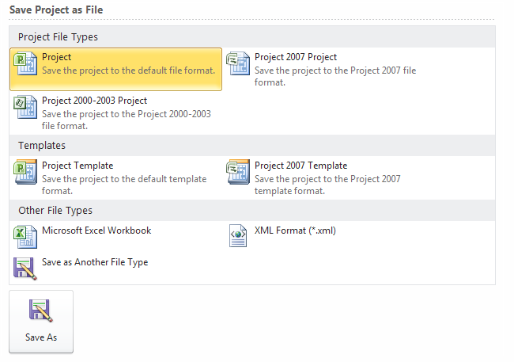
PLACEHOLDER
Create a PDF/XPS document: Click Create PDF/XPS, name the file and select PDF or XPS, click OK to complete the save.
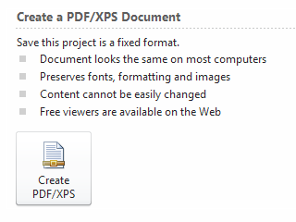
PLACEHOLDER
Saving the Schedule
Project 2010 provides multiple file formats for a project schedule. The steps to save a file are very similar to other MS Office files.
To save the Project 2010 schedule:
Click File → Save as → select file location
Enter the file name in the File Name area
Click Save to complete the save. The file will be given a Project 2010 default file extension of .mpp
There is also an option to save the Project 2010 schedule in an alternative file format. Some of the formats are:
MS Project 2007
MS Project 2000-2003
MS Project template 2010 - .mpt file extension
MS Project template 2007 - .mpt file extension
MS Excel
PDF
XPS
XML
CVS
Text
Save and Send Options
A new feature in Project 2010 is the Save and Send from the backstage view. These options are an easy method of saving projects and sharing project schedules with others. There is also an option to send project files as an attachment to an email as well as publishing the project schedule to a SharePoint site (Project 2010 Pro users only).
To navigate to the options available for Save and Send:
Click File → Save and Send → select one of the options offered
The right side of the screen will change as options are selected
PLACEHOLDER
Send as Attachment: sends the project schedule as an attachment to an Outlook email
Sync with Tasks List: use this option to synchronize with a task list in SharePoint. Team members can update task status and the updates can be synchronized back to the project schedule. The URL to the SharePoint site and the task list name will be needed at the time of the synchronization.
Save to Sharepoint: this option will save the project schedule to a Sharepoint site. (Project 2010 Pro users only)
Share with Project Online: used with Project Server and SharePoint
Save Project as a file: when clicked the right side of the view is shown below. There are several file type options available. Click Project and Save As to start the save process.
PLACEHOLDER
Create a PDF/XPS document: Click Create PDF/XPS, name the file and select PDF or XPS, click OK to complete the save.
PLACEHOLDER
Save and Send Options
A new feature in Project 2010 is the Save and Send from the backstage view. These options are an easy method of saving projects and sharing project schedules with others. There is also an option to send project files as an attachment to an email as well as publishing the project schedule to a SharePoint site (Project 2010 Pro users only).
To navigate to the options available for Save and Send:
Click File → Save and Send → select one of the options offered
The right side of the screen will change as options are selected
PLACEHOLDER
Save and Send Options
A new feature in Project 2010 is the Save and Send from the backstage view. These options are an easy method of saving projects and sharing project schedules with others. There is also an option to send project files as an attachment to an email as well as publishing the project schedule to a SharePoint site (Project 2010 Pro users only).
To navigate to the options available for Save and Send:
Click File → Save and Send → select one of the options offered
The right side of the screen will change as options are selected
PLACEHOLDER
Send as Attachment: sends the project schedule as an attachment to an Outlook email
Sync with Tasks List: use this option to synchronize with a task list in SharePoint. Team members can update task status and the updates can be synchronized back to the project schedule. The URL to the SharePoint site and the task list name will be needed at the time of the synchronization.
Save to Sharepoint: this option will save the project schedule to a Sharepoint site. (Project 2010 Pro users only)
Share with Project Online: used with Project Server and SharePoint
Save Project as a file: when clicked the right side of the view is shown below. There are several file type options available. Click Project and Save As to start the save process.
PLACEHOLDER
Create a PDF/XPS document: Click Create PDF/XPS, name the file and select PDF or XPS, click OK to complete the save.
PLACEHOLDER
Calendar Overview
Calendars in Project 2010 will determine when a task may be scheduled within the project schedule. It will also influence what defines a day, a week and a month. The calendars will also work hand-in-hand with the calendar options to determine when and how the tasks will be scheduled.
In this lesson we will explore:
How calendars work in Project 2010
How to create a base calendar
How to Set Working Hours and Days
How to Set Non-Working Hours and Days
How to Set Calendar Options
How Calendars Work in Project 2010?
There are several types of calendars within the Project 2010 system. The following are definitions of available calendars:
Base Calendar: The base calendar which may be used to as a template to create other calendars. A base calendar may also be used as a Project, Resource or Task calendar.
Project Calendar: The project calendar is the calendar assigned to a project and it defines the project working and non-working days. The default name for the Project Calendar is “Standard”.
Resource Calendar: Each resource will have its own calendar which may be based off of a base calendar or the project calendar. Unique resource calendars may also be created.
Task Calendar: A task calendar is assigned to a task to allow for the scheduling of that task in a unique timeframe. For example: tasks which have to occur on a weekend.
How the calendars are used by the software:
A task will be scheduled based on the Project calendar until a resource is assigned to the task. At that time, the Resource calendar will control the scheduling of most tasks. Unless – there is a task calendar assigned which will override the Project and the Resource calendars.
When a project schedule is created, a default calendar of “Standard” is applied to the schedule. This is called the project calendar for the project. The default values on the Standard calendar are: Monday through Friday which are working days, and working time is 8:00 am to 12:00 pm and 1:00 pm to 5:00 pm daily. No holidays are indicated on the calendar. The Standard calendar is also the calendar that will be viewed in the background of the Gantt Chart views. The Calendar Options work hand in hand with the Project Calendar to determine number of hours in a day or week and these values should be in sync with one another. The Calendar options will be discussed in the next section.
By default, 2 additional calendars are included in Project 2010: a 24 hour calendar and a Night Shift calendar. Either of these may be used as Project, Resource or Task calendars.
FAQ’s
Q: Why are there no holidays on the calendars?
A: This is an international program. Holidays vary from country to country.
Q: Is there the ability to add holidays to a calendar the way they can be added in Outlook?
A: No – this is not a capability of the software.
Q: Do I have to recreate the calendar for each project?
A: No – calendars may be created and saved through the Organizer to use in future projects.

The default calendar name for the system is “Standard”. If a different calendar name is selected, each Gantt view will also require changing because Gantt Chart views are set to display the Standard calendar. This change can be made by right clicking in the Gantt view and select Non-working time and changing to the calendar to be seen in the view. Most users keep the Standard calendar because of ease of use.
Setting Working Hours and Days
After the base calendar has been created, decide what the working days (business days) of the project schedule will be. Decide also, how many hours will make up a working day and what times the hours will be. By default, the working days of the calendar are Monday through Friday and the working time is 8:00 am to 12:00 pm and 1:00 pm to 5:00 pm daily or 8 hours working per day.
Ask yourself, how many hours per day do you feel your resources work productively on project work?
The average amount of productive project time in a day for a full time resource is 6 to 6.5 hours. If you are planning projects using an 8 hour day and your resources produce 6.5 hours per day are you planning an unreasonable timeline for your project schedule. After resources are assigned to tasks, the resource availability calendar will be considered in the scheduling equation and the timeline for the project schedule will alter substantially. It is expected that schedules will double in length once actual resources are assigned to tasks.
This difference to the schedule may be handled through adjustments to the project calendar, to the assignments or to the resource calendars. Consider choosing one of the methods and using it as the standard for scheduling projects. Each of the above options has their pros and cons, but it is the crossing of methods that will result in unreliable results in planning a schedule.
To Change the Working Hours of all Days on a Calendar:
Click Project → Change Working Time
Check to ensure the calendar you wish to change is displayed in the For calendar list
Click Work Weeks near the bottom of the dialogue box
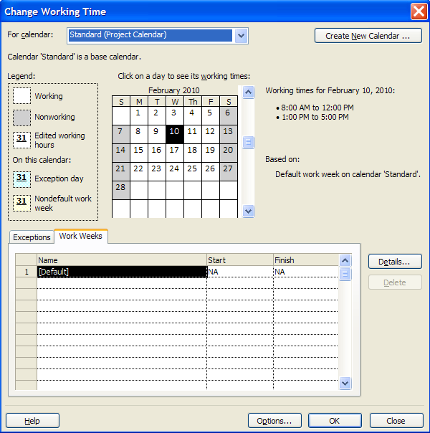
PLACEHOLDER
After clicking on the Work Weeks tab, the word Default should be highlighted. Click the Details button to the right of the form
Click Monday, press and hold the shift key and click on Friday. All of the working days will be selected
Click the 3rd radio button, Set day(s) to these specific working times
You will see the standard working times. Make changes to reflect the new values
Click Enter or Tab to move away from the value you have changed
Click OK to close the form
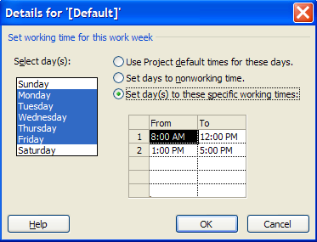
PLACEHOLDER
Military time is valid when entering hour values. To change 5:00 pm to 4:00 pm to shorten the work day, simply enter 16 where 5:00 pm is located and click Enter or Tab and 4:00 pm will appear.
Setting Non-Working Hours and Days
Non-working time is defined in the software as days where work will not be planned or performed. Examples are: national and organizational holidays, training days, company shutdowns, summer hours, etc. Adding these non-working days and times to the project calendar will allow for the scheduling of the tasks to be excluded from these dates.
A frequently asked question is: Is there the ability to add holidays to a calendar the way they can be added in Outlook? The answer is no - this is not a capability of the software. However, creating recurring holidays and non-working times is a feature of Project 2010.
How to Create a Non-working Day for a Calendar:
Click Project → Change Working Time
Check to ensure sure that the calendar you wish to change is displayed in the For Calendar field
Click Exceptions tab near the bottom of the dialogue box
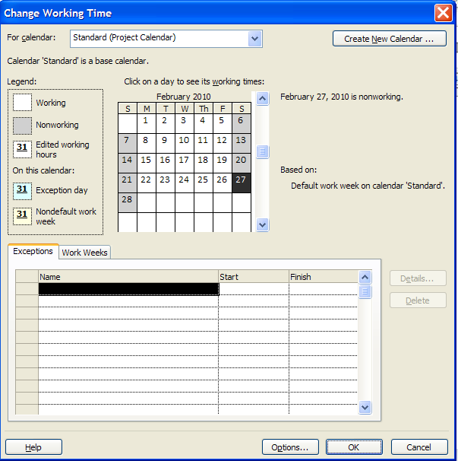
PLACEHOLDER
In this example, we will set April 8, 2011 as a non-working day. Move the slider on the right side of the calendar down until April 2011 is displayed in the calendar
Click April 8, 2011
Click in the name field and enter a reason for the non-working day, ie: Company holiday
Click Enter
Repeat for additional non-working days. See the result below
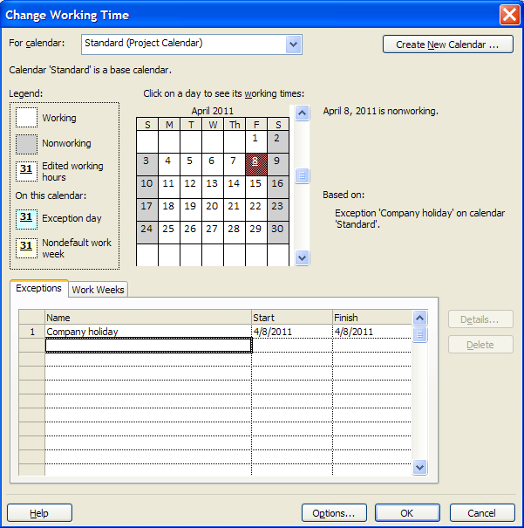
PLACEHOLDER
To Create a Recurring Non-working Day for a Calendar:
Click Project → Change Working Time
Check to make sure that the calendar you wish to change is showing in the For calendar field
Click Exceptions the tab near the bottom of the dialogue box
In this example, we will set January 1 (New Year’s Day) as a recurring non-working day. Move the slider on the right side of the calendar down until January 2013 is displayed on the calendar
Click January 1, 2013
Click in the first open line in the Name field and enter New Year’s Day for the non-working day
Click Enter
Click back on the words New Year’s Day and then click on the Details button to the right of the form
Click Yearly
Click on January 1
Enter the start date
Enter a recurrance value or an End by date
Click OK to close box
Check for the recurrance values in the Exceptions line for New Year’s Day.
Setting Calendar Options
The Calendar options work hand in hand with the project calendar to determine how tasks will be scheduled. It is imperative that the calendar options match the project calendar to create a consistency in the scheduling values for tasks and assignment values.
To access the Calendar options:
Click File → Options → Schedule
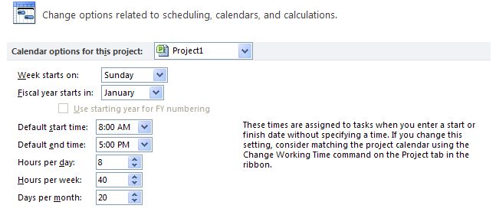
PLACEHOLDER
What the options mean:
Calendar options for this project: option to select whether your option choices for the calendar will be held within an individual project or if they will be applied to all new projects.
Week starts on: this choice will affect what is assigned and viewed as the first day of the week. The day chosen will be reflected on the Gantt Chart, Resource Usage, Task Usage and other calendar views.
Fiscal Year starts in: if using this option, select which month will be the start of the fiscal year.
Default start and end times: these values should match the time values on the project calendar. Assigning the project calendar will be discussed in the next lesson. The times stated here will be used to schedule tasks when time is not specified for a task. It will also be used to schedule tasks that do not use relationships. For example: if recurring tasks are created, the tasks will always be scheduled at the start time represented in this option.
Hours per day: when 1 day of work is scheduled, how many hours should 1 day consist of?
Hours per week: when 1 week of work is scheduled, how many hours should 1 week consist of?
Days per month: when 1 month of work is scheduled, how many days should 1 month consist of?
Saving the Calendar
In Project 2010, the calendar that was just created is known as a “custom object”. Custom or customized objects may be saved for use in the project the object was created in and used in other projects as well. To save objects the Organizer is used. When Project 2010 was installed on your system, a file named Global.mpt was created. The Organizer is the function that will copy objects into the Global.mpt as well as between project schedules. Calendars are only one of many object types that may be customized and saved for use in other project schedules. The other objects will be discussed in Module 10. In this lesson, we will only address the Calendar.
To save the custom or customized calendar, the object must be copied using the Organizer.
To copy a New Base Calendar into the Global.mpt:
Click File → Info → Organizer
Click the Calendars tab
Click New Base Calendar to the right and click <<Copy
Click Cancel to close the box
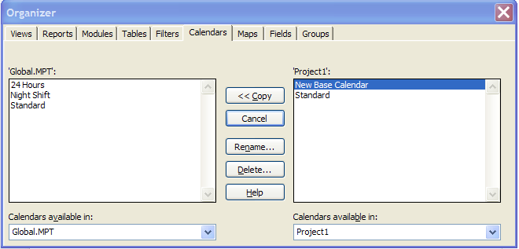
PLACEHOLDER
The Calendar will be copied into your local Global.mpt.
Practice: Creating Calendars
The Practice page is where you write detailed instructions for completing work listed as Exercises.
Type the Exercise Title and write a brief summary what the student will be doing in the exercise. Then list your ideas what they will be doing.
SAMPLE
In this practice you will create a Project Server Authentication profile and then configure the local cache settings in Project Professional 2007.
Exercise 1: Create Project Server Authentication Profile
In this exercise you will create Project Server authentication profile to connect to the Project Web Access site.
Perform the following exercise on the PS07 virtual machine.
From the Start menu, click All Programs → Microsoft Office → Microsoft Office Tools and click Microsoft Office Project Server 2007 Accounts.
In the Project Server Accounts dialog box, click Add.
In the Account Properties dialog box, and complete the following settings and click OK.
PLACEHOLDER
Setting | Perform the following:
Account Name | Type Project Server
Project Server URL | Type http://epm/pwa
When connecting | Select Use Windows user account
Set as default account | Select check box

Create New Calendar
Calendar Options
The Calendar options work hand in hand with the project calendar to determine how tasks will be scheduled. It is imperative that the calendar options match the project calendar to create a consistency in the scheduling values for tasks and assignment values.
To access the Calendar options:
Click File → Options → Schedule
PLACEHOLDER
What the options mean:
Calendar options for this project: option to select whether your option choices for the calendar will be held within an individual project or if they will be applied to all new projects.
Week starts on: this choice will affect what is assigned and viewed as the first day of the week. The day chosen will be reflected on the Gantt Chart, Resource Usage, Task Usage and other calendar views.
Fiscal Year starts in: if using this option, select which month will be the start of the fiscal year.
Default start and end times: these values should match the time values on the project calendar. Assigning the project calendar will be discussed in the next lesson. The times stated here will be used to schedule tasks when time is not specified for a task. It will also be used to schedule tasks that do not use relationships. For example: if recurring tasks are created, the tasks will always be scheduled at the start time represented in this option.
Hours per day: when 1 day of work is scheduled, how many hours should 1 day consist of?
Hours per week: when 1 week of work is scheduled, how many hours should 1 week consist of?
Days per month: when 1 month of work is scheduled, how many days should 1 month consist of?
Project Information
The final project information that should be entered before proceeding with project schedule development is the project start or project finish date as well as indicating which calendar will be used as the project calendar. This information is entered through the Project Information box.
To navigate to the Project Information dialogue box:
Click Project → Project Information
Deciding whether to enter the Project Start date or the Project Finish date will take some consideration. There are pros and cons to either choice:
FAQ: Should I enter a project start and finish date?
Answer: Project 2010 will accept either the start or the finish date but not both.
Entering a start date will indicate that you are planning your schedule as forward scheduling. This will result in:
All tasks will be scheduled As soon as possible
The work of the project will determine the project ending date
You will have a date to manage to and know when you are on time or late with the progress of the project
Entering a finish date will indicate that you are planning your schedule as backward scheduling. This will result in:
All tasks will be scheduled As late as possible
The ending date of the project will be locked to a date on the calendar
You might be planning a project where each task will be required to be completed as planned to achieve the ending date goals.
The most used planning method is that projects are planned from the project start date.
Project Calendar: The default calendar is “Standard”. Whatever calendar is selected will become the scheduling calendar for the project. All tasks will be scheduled using this calendar until a resource is assigned to the task.
Click OK to close the box.
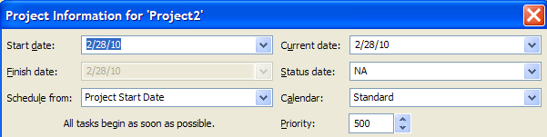
PLACEHOLDER
Most project managers have definite deadlines. Consider planning the schedule from ending date to get the schedule short term goals, deadlines and milestone dates. Then switch the project to the start date to manage. Reset the constraints to as soon as possible to enable the schedule to include slack and aid in schedule management.
Plan from Start

Plan from Finish

Project Start Date

Assign Project Calendar

Options
General V Per Project
General options are options which affect how the installation of Project 2010 on a desktop will operate. Display options are options that will help the user interface with Project 2010 software. The options selected are unique to each user and are a personal preference. These options do not have an influence on the ability to create a project schedule.
To navigate to General options:
Click File → Options → General
In the Project view section, the user may select the default view for usage of Project 2010 and the date format for dates for reports and views (tables).
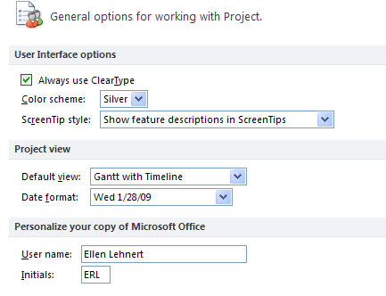
PLACEHOLDER
To navigate to Display options:
Click File → Options → Display
These options refer to which elements should be viewed on the screen. These options will control which indicators are shown in the indicator column, currency values and if the Entry bar is visible or not.
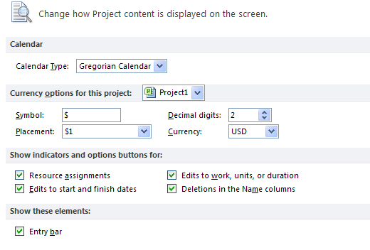
PLACEHOLDER
Additional display options are available at:
Click File → Options → Advanced
Some of the options that should be considered are:
Show this number of recent documents – optional number, list will show in the Recent tab in the backstage
Automatically add new views, tabls, filters and groups to the global - recommended
Settings for duration label values – Minutes, Days, etc. - may alter as needed
Show project summary task – recommended
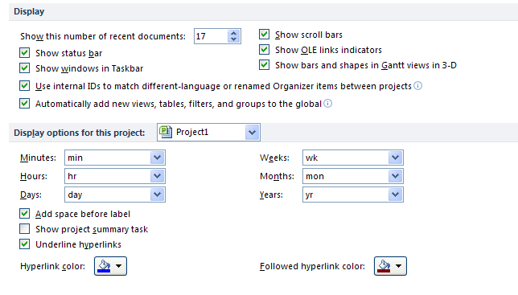
PLACEHOLDER
Each project schedule has the ability to contain a Project Summary task. The Project Summary task is a zero level task that will serve as a constant grand total for the project schedule. The setting in the above options may be used to turn on the project summary task or use the directions below.
To turn on the Project Summary task:
Click Task → Gantt Chart
Click Format → Project Summary Task (on the right side of the ribbon)
General: Change the Default View to Gantt Chart

Display: Entry Bar

Scheduling

Define Duration, Work, Task Types and Effort Driven
Scenario 1: Entering a Constant Duration Value
Let’s say you would like to enter a duration value that remains constant regardless of the resources that are added or subtracted.
The recommended practice is to estimate the task by entering a duration value, set the task type to Fixed Duration and then assign the resources.
This will cause total work for the task to be calculated.
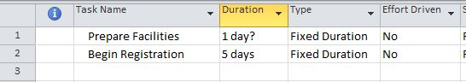
Entry Table with Duration and Optional Fields
The Effort Driven option provides a shortcut to divide the total work for the task across the resources assigned. This is useful for organizations that track costs or track resource assignments in detail.
To follow this approach, insert the Type and Effort Driven columns in the Entry table of Gantt Chart view or display Task Entry view which provides these fields in the lower pane. For more information about modifying views, refer to chapter 7, Using Views.
Scenario 2: Entering a Constant Work Value
You also have the choice to enter a total work value for the task that remains constant regardless of the resources that are added or subtracted. This is also called effort-driven estimating.
The recommended practice is to estimate the task by entering a Work value, set the task type to Fixed Work, and then assign the resources.
This will cause total duration for the task to be calculated.
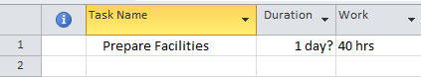
Entry Table with Work Field
To follow this approach, insert the Work column in the Entry table of Gantt Chart view. This is where you will enter your total Work estimate.

Do not enter anything in the Duration field. The Type field is also needed and may be inserted as a column or displayed in Task Entry view.

For more information about modifying views, refer to chapter 7, Using Views.
For a more detailed discussion of Task Types, refer to chapter 17, Working with Resources and Task Types.
Task Types, Effort-Driven
Scheduling options are per project options which establish the defaults how a project will be scheduled. These options are unique per project and should be checked before entering tasks into a project schedule. These options also may be changed at any time over the life of the project schedule.
To set the scheduling options:
Click File → Options → Schedule
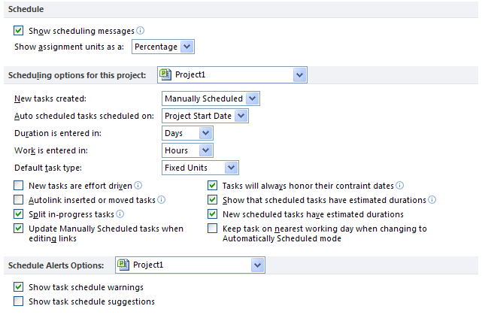
PLACEHOLDER
Show scheduling messages: gives the scheduler error messages concerning scheduling inconsistencies and warnings.
Show assignment units as a: options are percentage or decimal. This is user preference. It may be changed at any time without affecting the schedule.
Scheduling options for this project: options that can be assigned to a specific project or all projects.
New tasks created: manually scheduled or automatically scheduled. This is the default value and may be adjusted per task.
Manually scheduled: tasks will be entered without a start or finish date and without task duration. All values are entered manually.
Auto scheduled: tasks will be entered with a default duration of 1 day and a start and finish date.
Auto scheduled tasks scheduled on: project state date or current date. If you are managing a long project it might be easier to change this option for all new tasks to start on the current date.
Duration is entered in: minutes, hours, days, weeks, months
Work is entered in: minutes, hours, days, weeks, months
Default task type: Fixed Units, Fixed Duration, or Fixed Work
New tasks are effort driven: check for yes
Update Manually Scheduled tasks when updating links: when tasks are manually scheduled should the project schedule successor tasks based on realtionship links
It is a good idea within an organization to establish a standard for Duration and Work. When duration is discussed or appears on a report it will be easier for stakeholders to understand that duration always means hours or the value that works for the specific project. If you have a 3 year project, you probably will not be planning work at the hour level so weeks might be the duration standard.
Change to Auto Schedule
The column or field in Project 2010 that determines which scheduling mode a task will be scheduled by is called “Task Mode”. By default, you will see this field on the Entry table of the Gantt Chart. This column may be added to any task table.
Setting the automatic or manual scheduling mode may be accomplished in several ways:
To set the scheduling mode for a project or for all future projects:
File → Options → Schedule
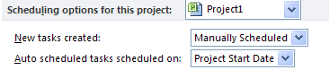
PLACEHOLDER
After several tasks are entered you may decide to switch to a different scheduling mode for the addition of future tasks for the project. This can be done quickly using the choice option at the bottom left hand corner of the Gantt Chart view which is shown below. Changing this option will not affect existing tasks in the schedule; it will only affect future added tasks. Click on the button highlighted below for the option to change scheduling modes:
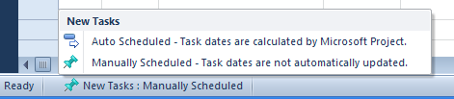
PLACEHOLDER
The default Entry Table for the Gantt Chart includes the “Task Mode” column inserted to the left of the Task Name column. This column may be inserted into any table as needed.. The indicators in this column indicate the scheduling mode for the task. In the view below the automatically scheduled tasks have a icon and the manually scheduled tasks have a icon in the Task Mode column. Hover your mouse pointer over the icon and the scheduling mode description will appear. Clicking on the icon will allow for scheduling mode changes per task. Note the different Gantt bar formats for manual v automatically scheduled tasks.
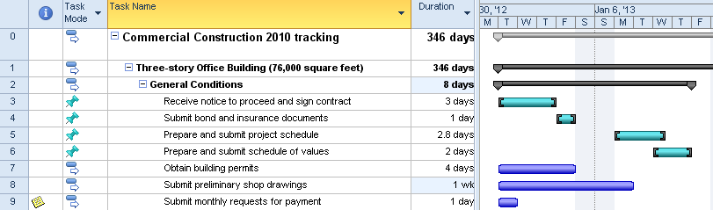
PLACEHOLDER
To change the scheduling mode from the Task ribbon:
Click task to be changed
Click Task → Manual Schedule or Automatic Schedule
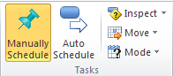
PLACEHOLDER
Another way to change the schedulig mode is to double clicking a task to open the Task Information dialogue box. An option is located on the General tab to change the scheduling mode. The options are highlighted in the view below.
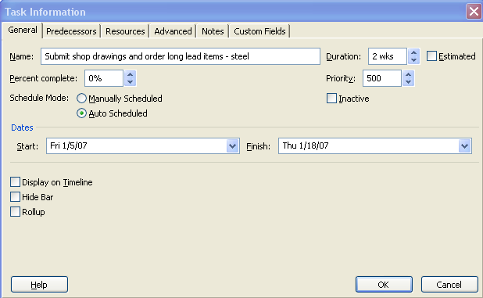
PLACEHOLDER

